**USER MANUAL:**

**POINT-OF-SALE SYSTEM**

Submitted by:

Lovelyn Perez

BSIT 1 – C

December 18, 2020

Step 1: Opening the executable file, it would show that it needs the user to input their name. After typing the name click “enter” to proceed.

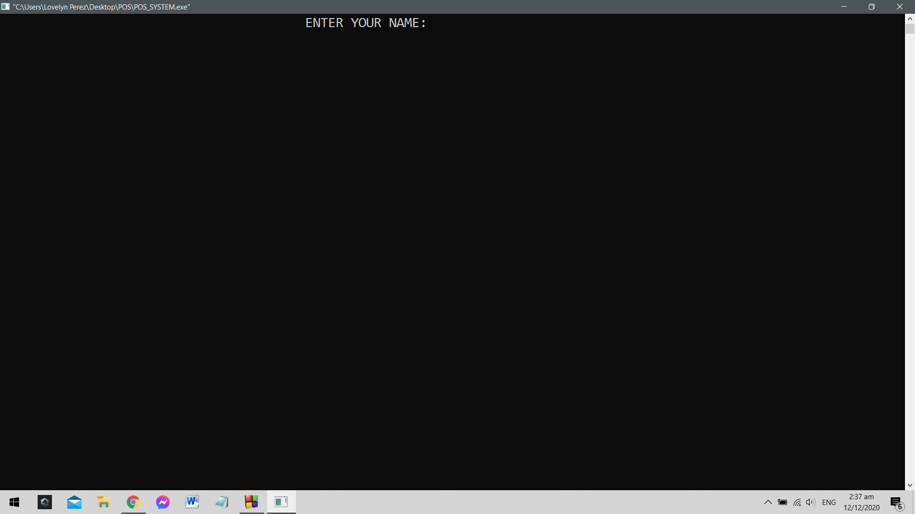

Step 2: Right after clicking “enter”, it would ask for the PIN number of the POS System. The default PIN number is 1234, the user has to input the PIN number so they will be redirected to the main menu board of the products.

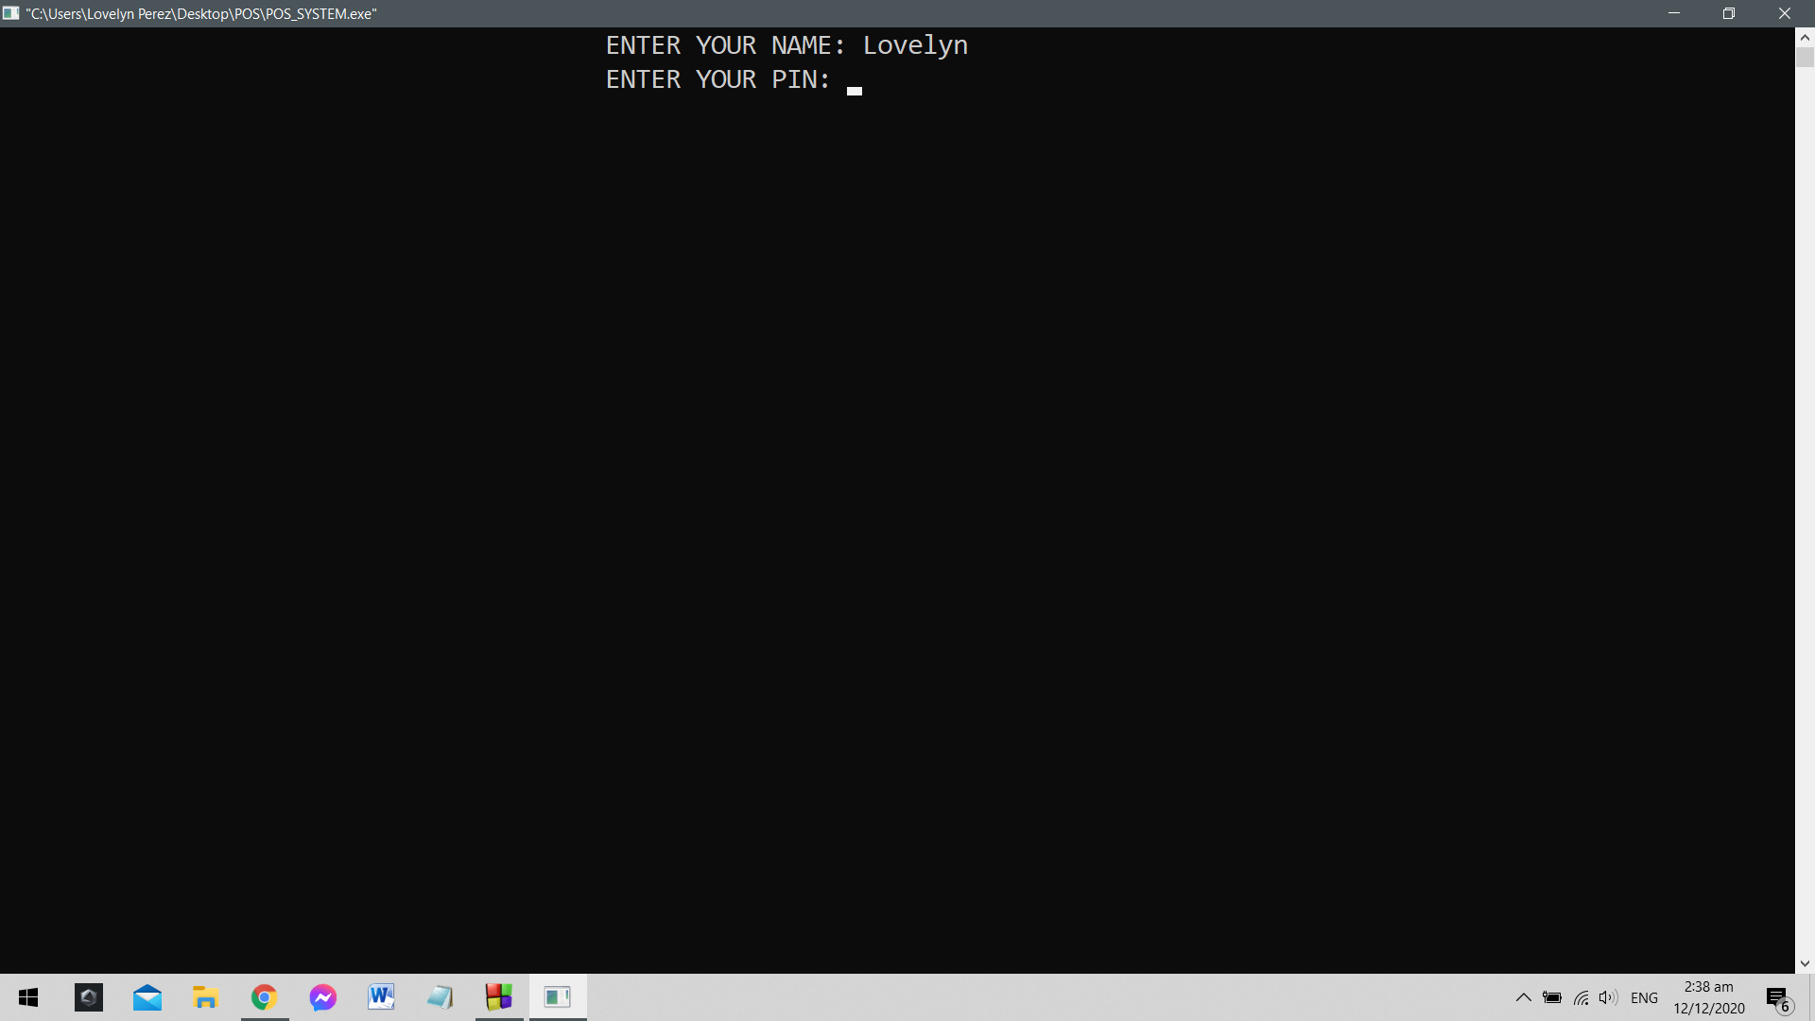

*Note: Be aware of typing the PIN number before clicking “enter”. Making a mistake typing the PIN number won’t let the user to access the whole system. The example is shown below:*

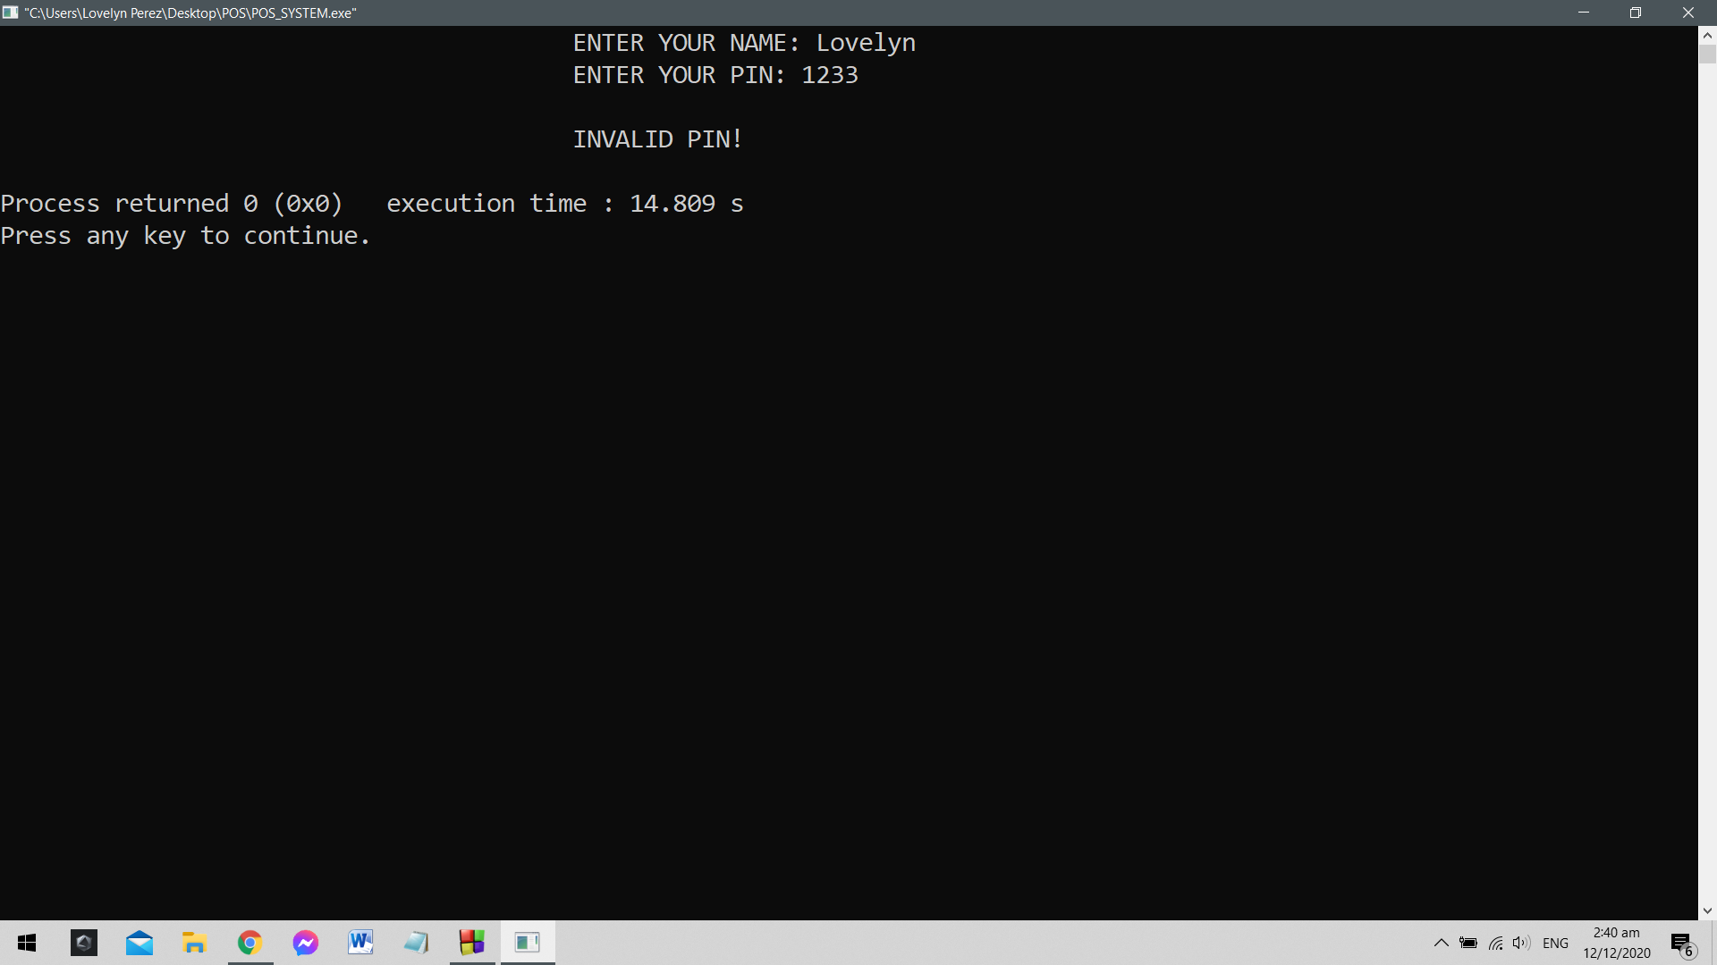

Step 3: When the menu board comes into view, the user should input the customer’s order using the product code seen on the far left side of the screen.

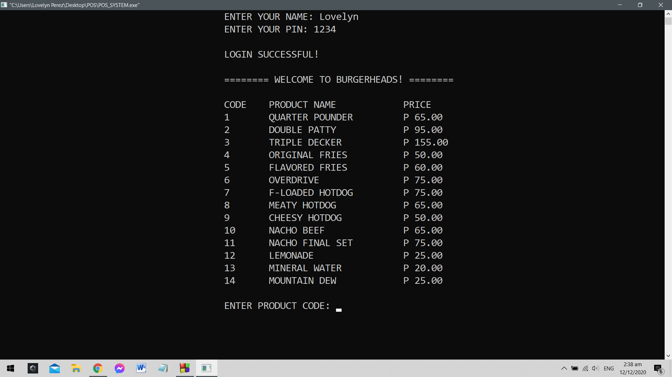

Step 4: After getting the customer’s order, it would show the name and the price of the order they made. Next would be the quantity. The system then would ask the customer how many of the chosen item they wish to buy. Right after placing the quantity, the *Add-Ons board* will show. Like the menu board before, the user has to put the product code of the add-on the customer wants to add on their chosen food.

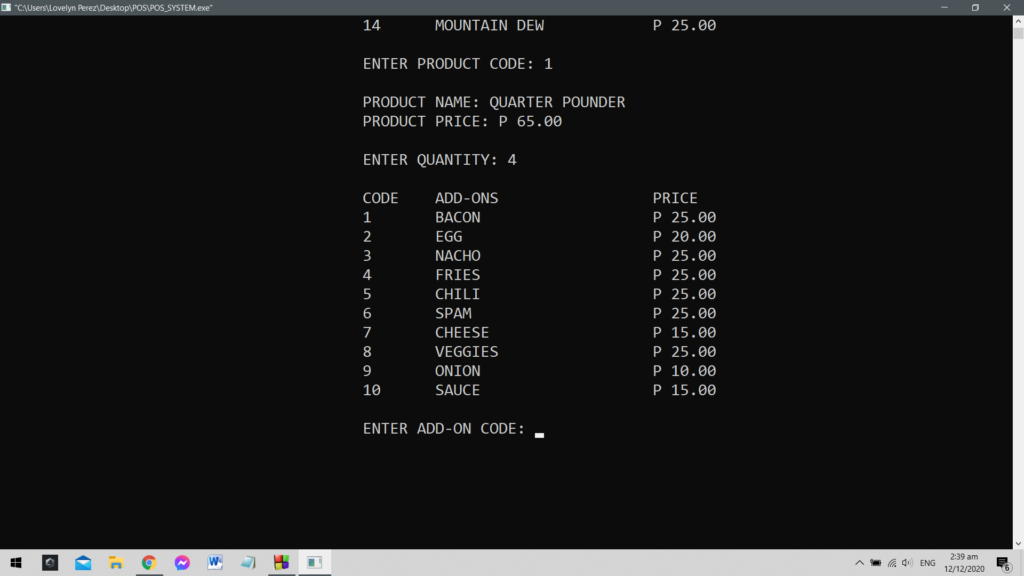

*Note: If the customer chose to have nothing to add, input “0” to record none.*

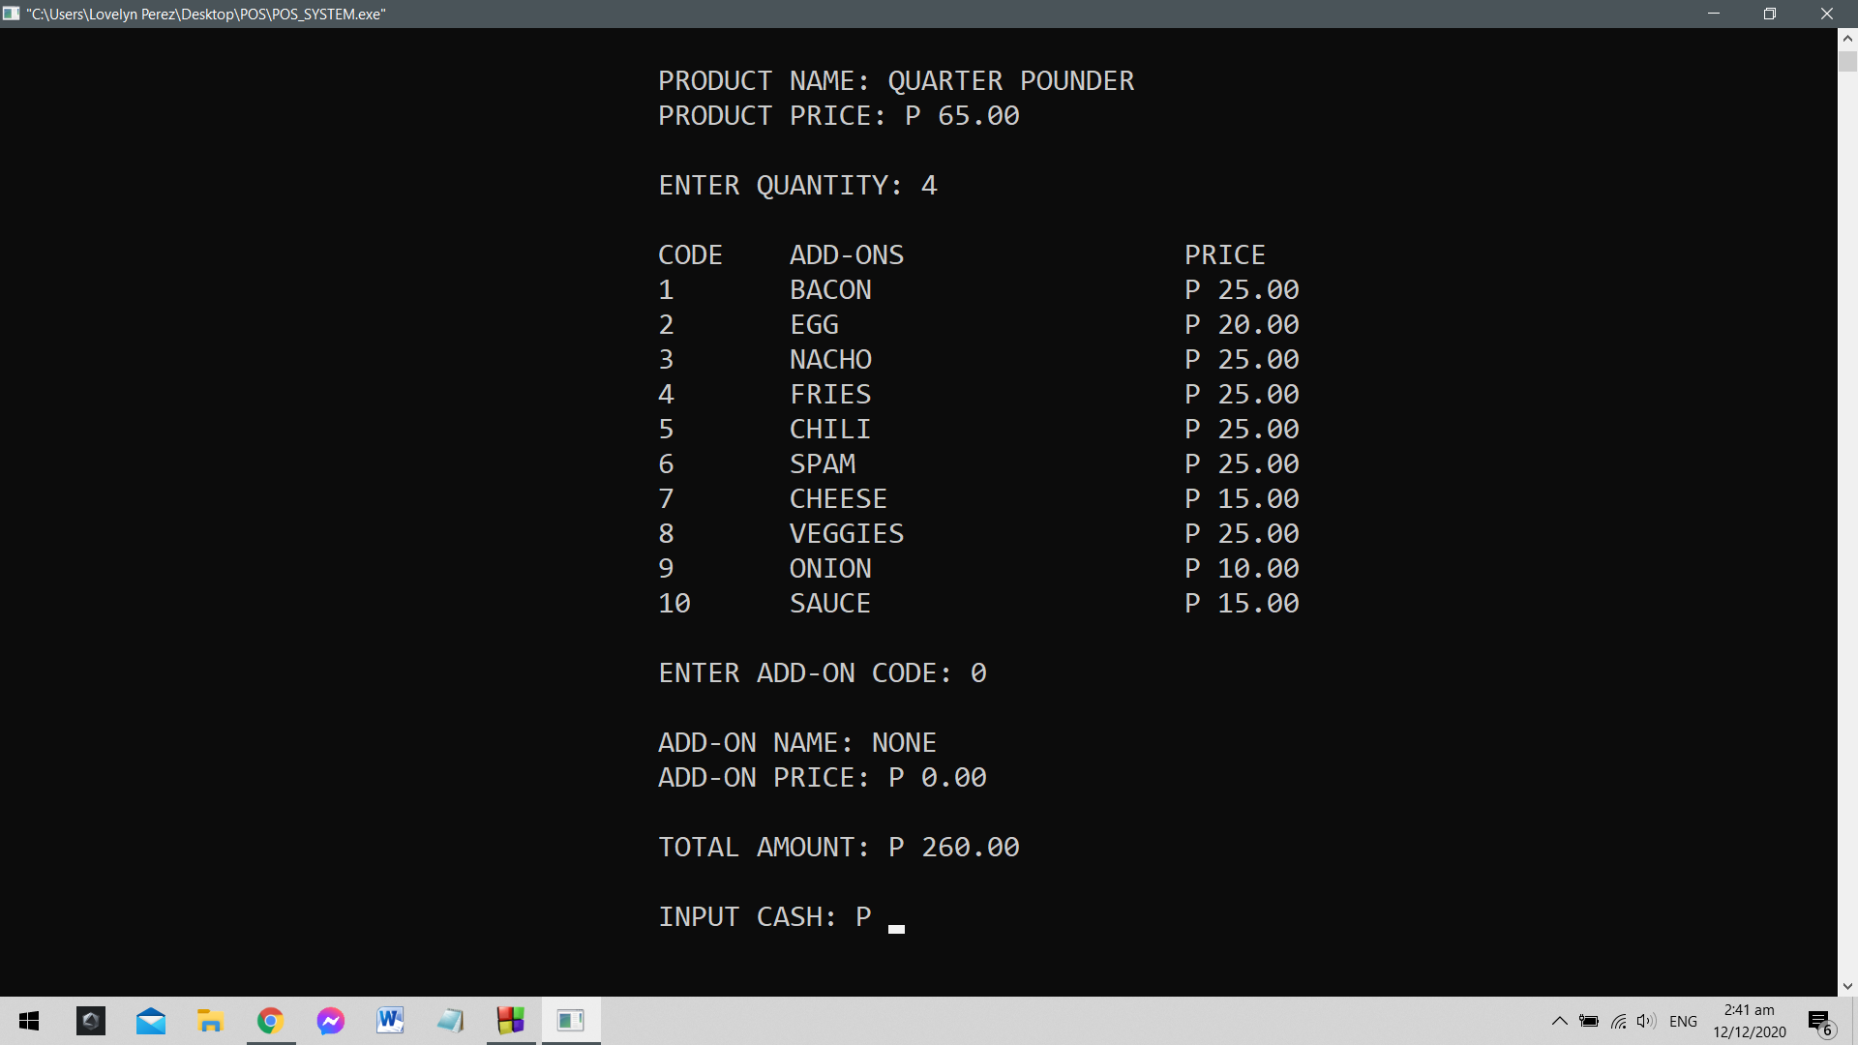

Step 5: However, if the customer did choose an add-on, it will show the name and the price of the chosen add-on and would multiply the item’s price to the quantity they chose. The product then would be added to the price of the add-on they have chosen and is now under *total amount* which is shown below. After the *total amount*, it will ask the user to input the cash.

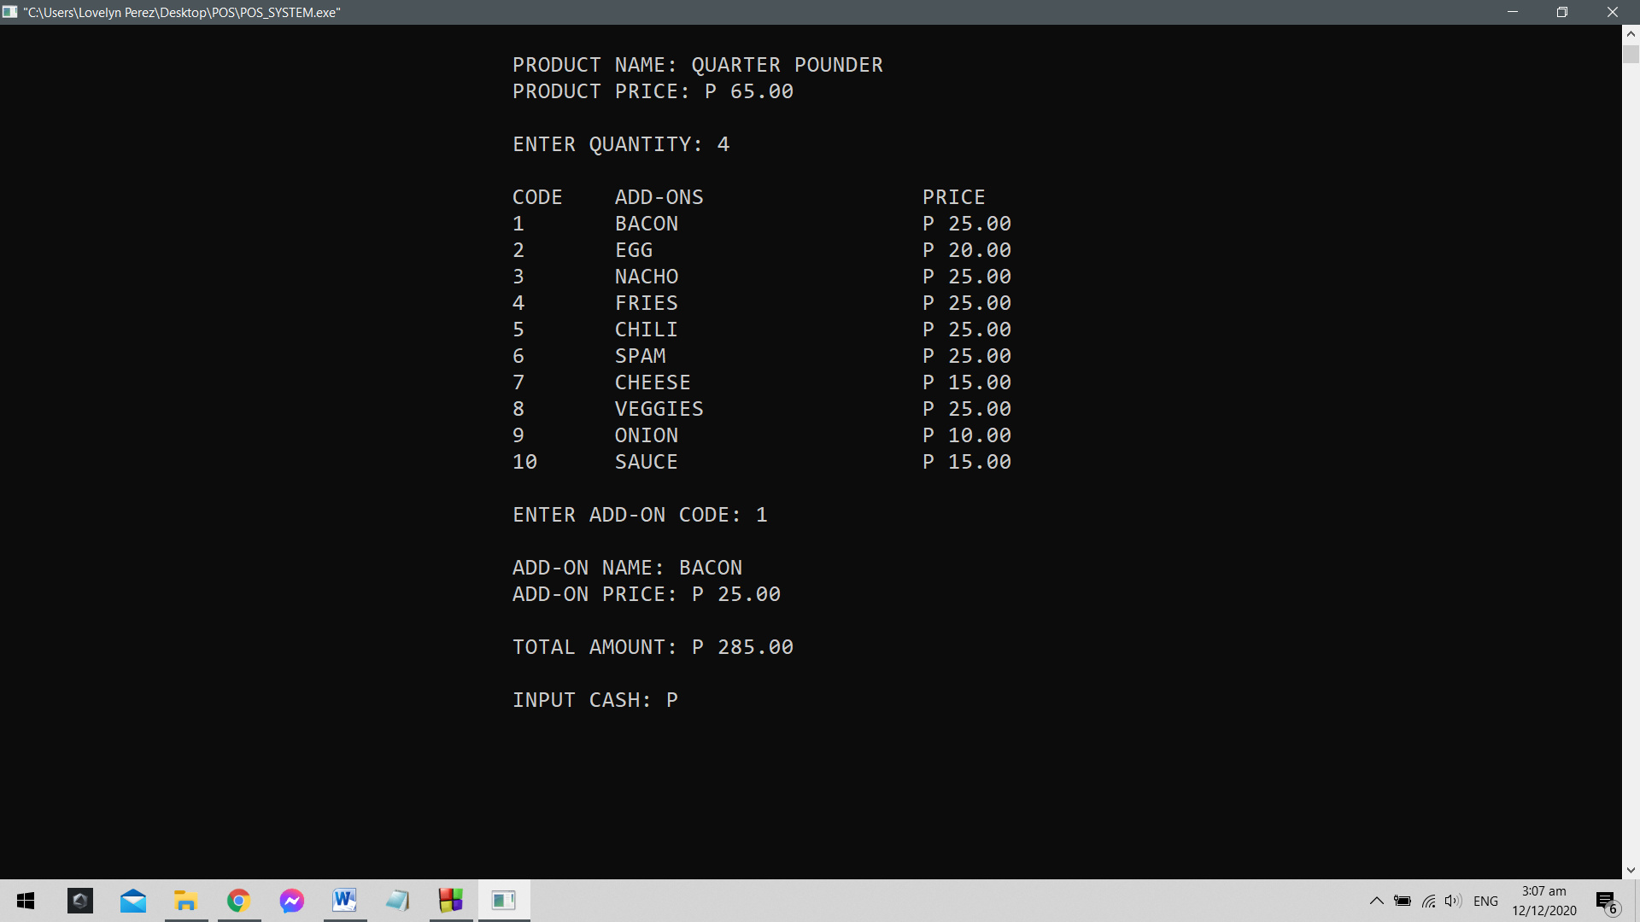

Step 6 A: If the user have put in cash bigger than the *total amount*, the system would show how much change is needed to be given back to the customer.

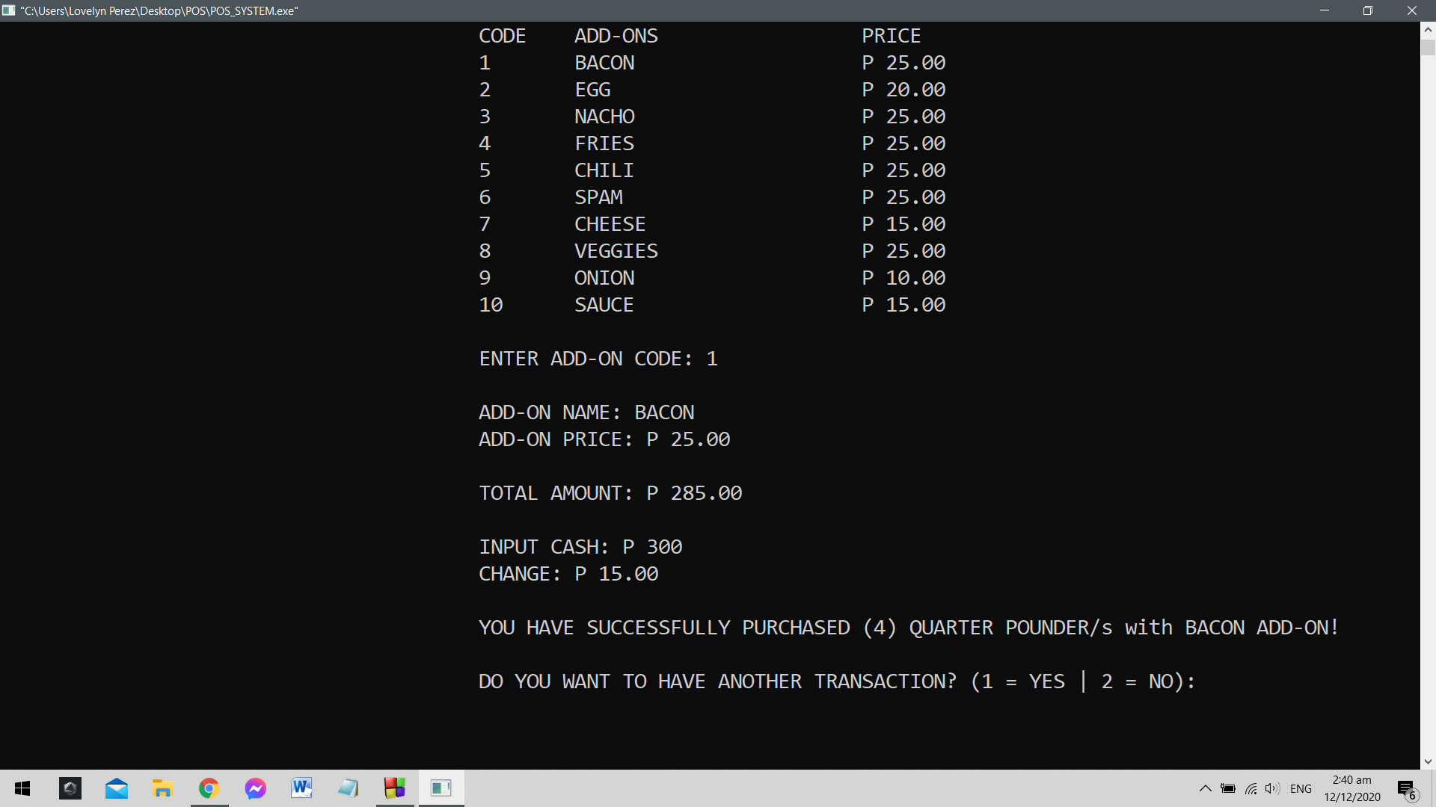

Step 6 B: If the user has inserted the exact and equal amount needed to purchase the chosen item, then the change would automatically be zero.

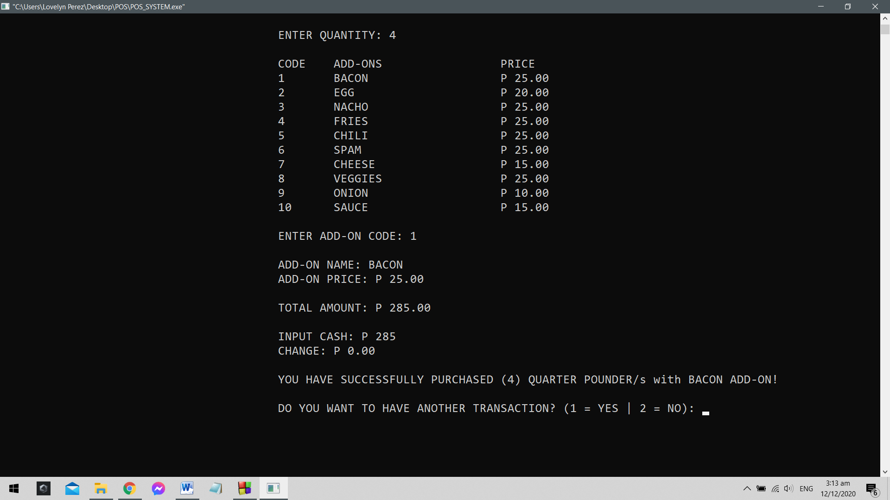

Step 6 C: If the user stored cash lesser than the total amount of price needed to purchase then it would show that the user has *insufficient funds* and it will go back to how much money the user has to input. This cycle would continue until the user has met the total amount needed.

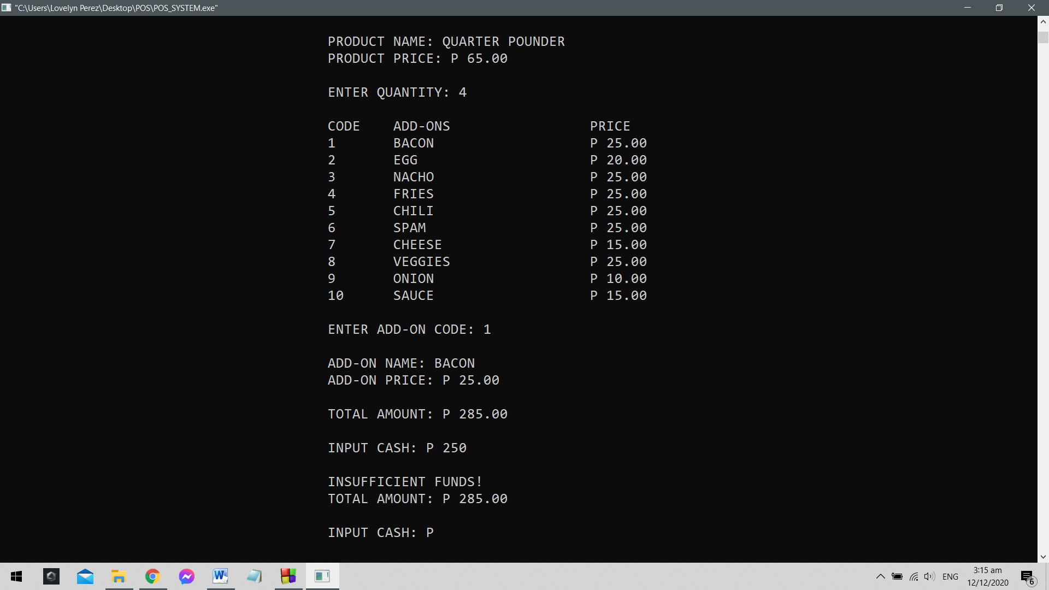

Step 7: After inserting the cash to meet the amount for purchase, the system would show how much change the customer has along with the number of the chosen item, its item name and add-on. Below the indication of purchase, the system would ask the user if they want to create another transaction using “1” for *yes* and “2” for *no*.

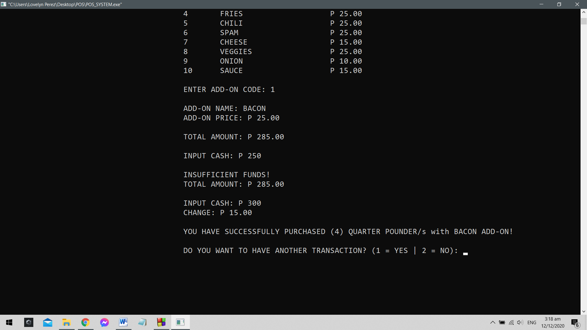

Step 8 A: If the user is done using the system, they may click the number “2” to end the execution of the POS system.

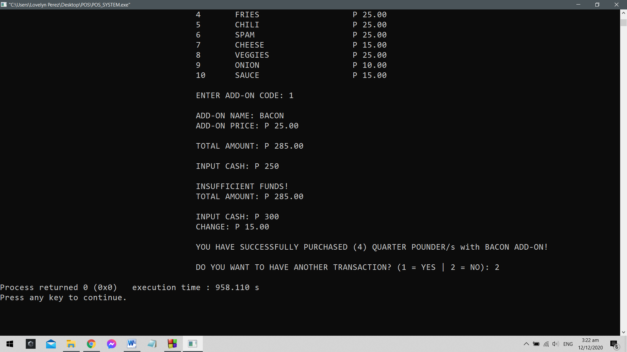

Step 8 B: However, if the user wishes to make another purchase, clicking the number “1” would show them the menu board of the products earlier thus, enabling the user to choose items for the second time.

This cycle would continue on unless the user decided to end the transaction by clicking the number “2”.

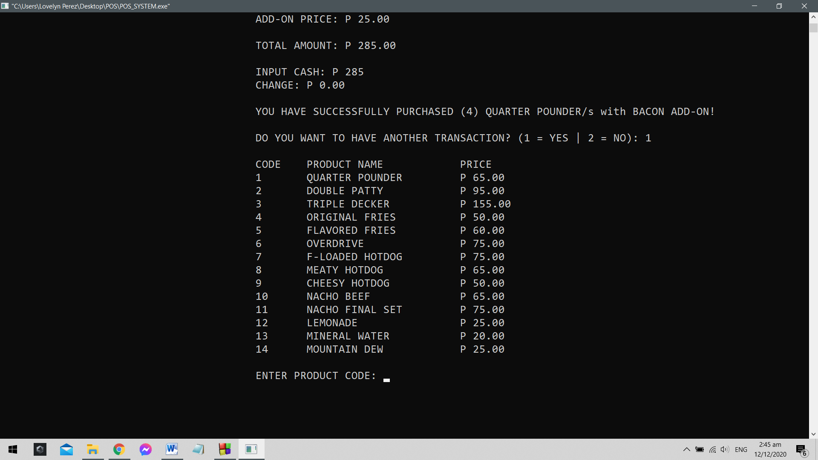

On the user’s computer in the same folder as the source code and executable file is the receipt. Note: The receipt would only be available after making a transaction. Without any transaction made, this file is non-existent,

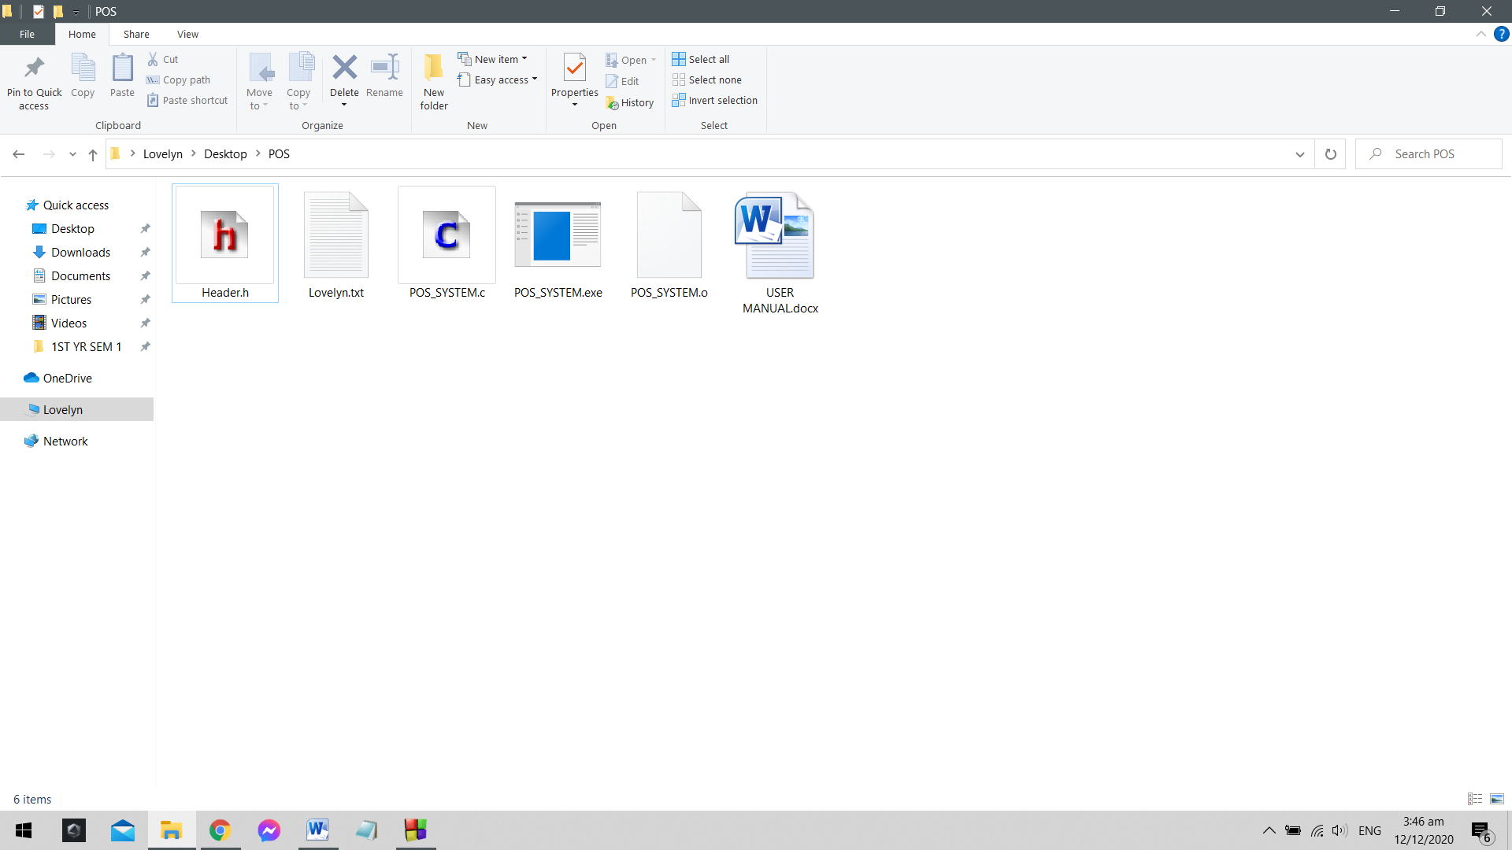

Open the receipt under the name it has been given. In this case, the programmer used her own name as the default name of the receipt with the chosen file extension as .txt, click the file to view the receipt of the recent purchases.

